**TASK 1: GLOBAL POPULATION ESTIMATION AND PROJECTIONS**

**1. Scenario Summary**

This report outlines the development of an interactive dashboard aimed at visualizing global population dynamics using a dataset containing key demographic indicators from 1960 to 2022, along with projections for 2023 to 2050. The dashboard is designed for policymakers and the public to facilitate understanding of population trends, with a specific focus on urban versus rural populations. By aggregating data based on regional and income groupings, the dashboard aims to highlight significant demographic changes and assist in informed decision-making.

**2. Introduction to the Scenario and Project Objectives**

In today’s rapidly changing world, population dynamics have become crucial to understanding global challenges such as urbanization, economic development, and sustainability (World Population Review, 2023). As a data analyst working with a non-governmental organization (NGO) focused on these demographic shifts, the task was to developed an interactive dashboard to visualize and analyze global population trends. The dashboard presents a range of data visualizations and statistics that enable a detailed understanding of the global population dynamics. The choice of visualizations is well-aligned with the objectives of providing a comprehensive overview of global population statistics and demographics.

The data spans both historical (1960-2022) and projected (2023-2050) population estimates, offering valuable insights into past growth patterns and future expectations. This dashboard, tailored for policymakers and the general public, provides an accessible, single-screen interface that enables users to explore demographic indicators across different regions and income groups. By examining these trends, the goal is to empower stakeholders with insights that can guide informed policy decisions.

For the dashboard, the following specific objectives were defined:

1. Compare urban and rural population growth trends across different regions.
2. Analyze the correlation between urbanization and life expectancy.
3. Present projected population growth for selected countries and regions.

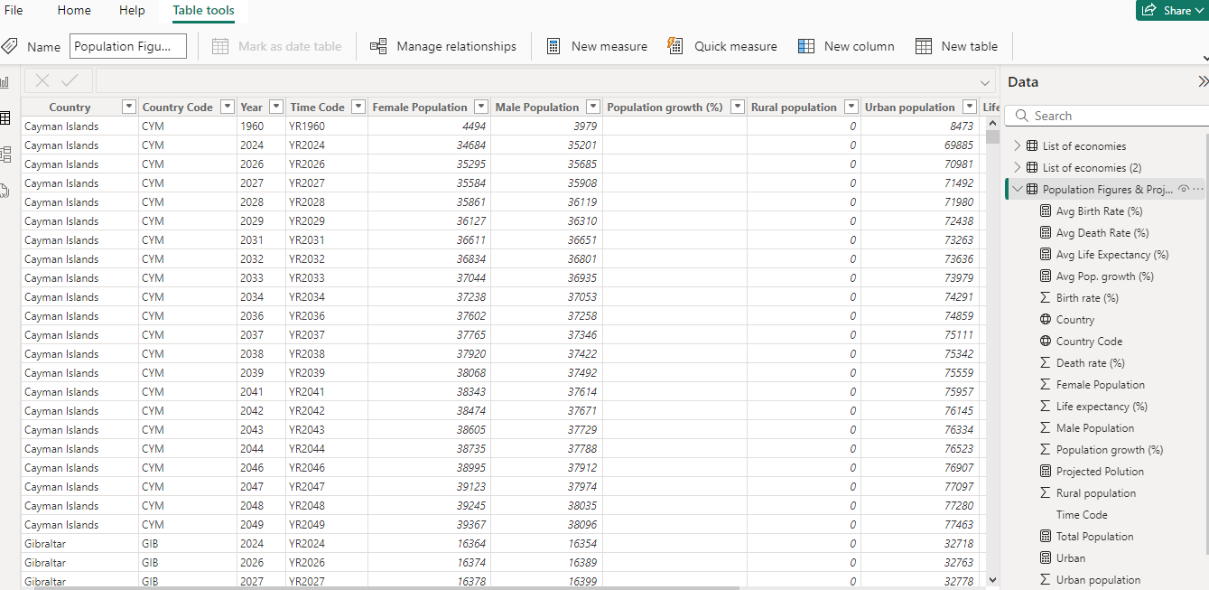

**3. Exploring the Data and Defining Objectives**

In exploring the provided dataset, which includes historical and projected population indicators, the study sought to identify patterns and focal points that would shape the dashboard’s objectives. Initial exploration revealed significant variation in population growth across regions, income levels, and urban versus rural divisions. Notably, certain regions are projected to experience rapid urbanization, while others show slower growth trends. Based on these findings, the study refined the dashboard’s objectives to highlight these contrasts and trends, allowing users to filter and interact with the data to explore specific aspects of population dynamics. This dashboard, tailored for policymakers and the general public, offers an accessible, single-screen interface that enables users to explore demographic indicators across different regions and income groups.

Furthermore, the dashboard categorizes the population by income group, showcasing the socioeconomic disparities within the global population. This data can guide policymakers in addressing issues of inequality and promoting inclusive economic growth. The dashboard also reflects the ongoing urbanization trend, with implications for urban planning, infrastructure development, and the provision of basic services. This approach not only aligns with the organization's goal to communicate complex data clearly but also provides a foundation for future policy discussions. By consolidating these essential population statistics and trends, the dashboard equips users with the necessary information to navigate the complex and rapidly evolving global landscape, ultimately contributing to more informed decision-making and the development of sustainable solutions.

**3. Justification for Visualization Choices**

The selection and design of the data visualizations in this global population estimates and projections dashboard are well-grounded in data visualization theory and best practices. The designer has thoughtfully incorporated various principles to ensure the effective communication of the complex population data. Firstly, the use of the world map, with varying shades of blue to represent the total population by country, leverages the principle of perceptual saliency. The contrast between the colors and the clear geographical boundaries allows users to quickly identify and compare the relative sizes of different countries, a crucial aspect of demographic analysis (Few, 2012). Moving on, the pie chart depicting the total population by income group adheres to the principle of proportional representation. The size of each slice corresponds to the relative size of the respective income group, effectively communicating the distribution and relative magnitudes of different population segments (Tufte, 2001).

The donut chart comparing the rural and urban population aligns with the principle of comparison and contrast. By presenting the two categories side-by-side, the visualization enables users to easily identify and compare the proportions of rural and urban inhabitants, a critical aspect of understanding demographic shifts. The bar chart displaying the total population by region follows the principle of hierarchical organization, grouping the data into broader geographic categories. This structure helps users quickly grasp the overall distribution of the global population and identify the most populous regions (Few, 2012). Lastly, the table showcasing the top 10 most populous countries adheres to the principle of tabular presentation, which is effective in conveying detailed, numerical information in a structured and easily digestible format. This approach allows users to compare and contrast the specific demographic indicators for each country (Few, 2012). These visualizations were chosen based on principles of clarity, simplicity, and effectiveness in presenting complex data. The combination of different chart types allows for a comprehensive understanding of the data from multiple perspectives.

**4. Overview of Dashboard Design and Layout**

To create a user-friendly dashboard that meets the needs of policymakers and the public, the study applied key principles of layout and design. The dashboard is thoughtfully structured to present the most critical metrics at the top, where key performance indicators (KPIs) summarize essential information such as population totals, growth rates, and life expectancy. This arrangement allows users to quickly grasp the overarching trends and figures that are vital for decision-making. Interactive elements, including slicers and filters, are incorporated to allow users to narrow down data by region, income group, or specific years. This functionality supports a more tailored exploration of the data, enabling users to focus on the aspects most relevant to their needs. For instance, a policymaker interested in urbanization trends can filter the data to examine specific metropolitan areas over particular time frames, providing a deeper understanding of regional dynamics. The color scheme used in the dashboard employs contrasting hues to distinguish between different data categories while maintaining a cohesive and consistent theme. This thoughtful use of color not only enhances visual appeal but also aids readability, ensuring that users can easily interpret the information presented. Moreover, the layout is designed to minimize visual clutter and distractions, following best practices in data visualization and dashboard design. By organizing content logically and using whitespace effectively, the dashboard ensures that users can navigate it intuitively, accessing relevant insights with ease.

**5. Step-by-Step Dashboard Creation and Advanced Features**

The step-by-step dashboard construction for the study involved five step which are data preparation, data modeling, visualization creation, interactive features and final touches.

**5.1 Data Preparation**

Under data preparation, the population dataset and country groupings were imported into Power BI. After that, missing values were addressed, and necessary transformations were performed to ensure data integrity.

**5.2 Data Modeling**

After data preparation, the next is to established relationships between the population data and country groupings to facilitate aggregated analysis. The study then creates measures using Data Analysis Expressions (DAX) to calculate average population growth rates, birth and death rates, and life expectancy by region and income group.

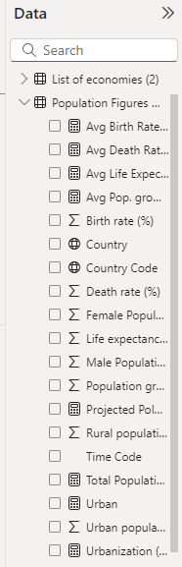

First, the study calculated core statistics essential for understanding demographic trends, including total population, average population growth, average life expectancy, average death rate, and average birth rate for each country, region, and income group. By utilizing DAX functions such as SUM, AVERAGE, and CALCULATE, the study was able to derive high-level insights across these critical demographic indicators. These calculated measures form the foundation of the dashboard, offering users a clear view of the population landscape. To enhance the dashboard's functionality, the study implemented conditional formatting using custom DAX rules. This feature was particularly useful for key metrics like death rate and birth rate, where the study established thresholds to highlight values that fell above or below set limits. Utilizing DAX functions such as IF and SWITCH allowed the study to set specific color conditions, making it easier for users to identify trends and anomalies at a glance. Moreover, the study added interactivity to the dashboard through the inclusion of slicers for year, region, and income group. These slicers, driven by DAX measures, enable dynamic adjustments to the dashboard visuals based on user selections. The use of DAX functions like FILTER facilitated these interactions, ensuring that the KPIs, charts, and maps updated in real-time as users explored different segments of the data.

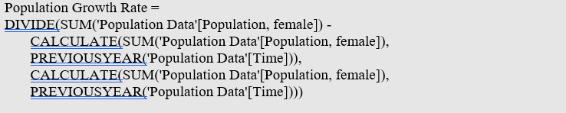

**5.3 Visualization Creation**

In the process of creating visualizations for the dashboard, the study employed a variety of chart types to effectively convey different aspects of population dynamics. To illustrate population trends over time, the study created line charts that specifically highlight the changes in both urban and rural populations. Bar charts were developed to facilitate comparisons of growth rates among various regions. Additionally, the study constructed scatter plots to analyze the correlation between urbanization and life expectancy. To provide geographic context to the population data, I implemented map visualizations.

**5.4 Interactive Features**

One of the primary interactive elements is the use of slicers. These allow users to filter data according to specific criteria, such as region, income group, and year. By enabling such filtering options, users can focus on particular segments of the population data that are most relevant to their interests. Additionally, the study implemented drill-down capabilities within the charts. This feature enables hierarchical navigation, allowing users to explore the data at various levels of granularity.

**5.5 Final Touches**

In the final stages of developing the dashboard, the study focused on refining the overall presentation and user experience through careful formatting and enhanced interactivity. Firstly, the study paid close attention to dashboard formatting, ensuring that all visualizations were consistently aligned and appropriately sized for maximum clarity. Additionally, the study customized tooltips to provide users with extra context and information when they hover over specific data points.

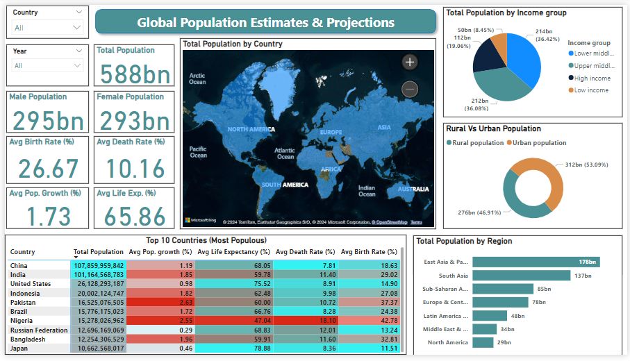

*Figure 1: Final Dashboard Screenshot*

**6. Conclusion and Recommendations**

The dashboard revealed the current global population was 588bn, with a breakdown of 295bn males and 293bn females. Average birth rate was 26.67%, average death rate was 10.16% and average population growth was 1.73% while average life expectancy was 65.86%. The world map visualization highlights the uneven distribution of the global population, with certain regions and countries being more populous than others. The pie chart categorizing the population by income group showcases the socioeconomic disparities within the global population. The pie chart characterizes the total population by income group into low income, lower middle income, upper middle income and high income. Lower middle income has the highest population by income group of 214bn (36.42%), follow by upper middle income with 212bn (36.08%) and high income with 112bn (19.06%) and low income has the lowest with 50bn (8.45%). The donut chart illustrating the rural and urban population balance reflects the ongoing urbanization trend, which has significant implications for urban planning, infrastructure development, and the provision of basic services (UN-Habitat, 2020). The urban population has the highest figure of 312bn (53.09%) while rural population was 276bn (46.91%). The bar chart presenting the total population by region allows for the identification of the most populous areas. It highlights the dominance of east Asia (178bn) and South Asia (137bn), which accounts for over 60% of the world's population, followed by Sub-Saharan Africa (85bn) and Europe (78bn). The demographic indicators of the world's most populous nations provide valuable insights for global organizations, multinational corporations, and policymakers to tailor their strategies and operations accordingly. The 10 most populous countries are China, India, United States, Indonesia, Pakistan, Brazil, Nigeria, Russian Federation, Bangladesh and Japan.

**References**

Few, S. (2012). Show Me the Numbers: Designing Tables and Graphs to Enlighten (Analytics, Oakland, CA).

Tufte, E. R. (2001). The visual display of quantitative information (2nd ed.). Graphics Press.

UN-Habitat. (2020). World Cities Report 2020: The Value of Sustainable Urbanization. <https://unhabitat.org/world-cities-report-2020>

World Population Review (2023). World Population. <https://worldpopulationreview.com/>